

**YOUR QUALITY PARTNER FOR SOFTWARE SOLUTIONS**

Opensky’s Request for Proposal

**TMA’s Responses**

**WWW.TMASOLUTIONS.COM**

# Contents

Contents 1

1. Company Name 3

2. Locations 3

3. Industry Experience 4

3.1. Telecom 4

3.2. E-commerce, Retail & Distribution 4

3.3. Finance & Insurance 4

3.4. Education 4

3.5. Healthcare 4

3.6. Media & Publishing 4

3.7. ISV (Independent Software Vendors) 5

3.8. Hospitality & Travel 5

3.9. Logistics & Transportation 5

4. Technology Experience 5

4.1 Microsoft Technologies 5

4.2 Java 5

4.3 Open Source 5

4.4 Mobile Applications 6

4.5 Front-end Development 6

4.6 BI, Big Data and Analytics 6

4.7 Internet of Things 7

4.8 Cloud Application and Migration 7

5. Offshore Rate 7

6. Sample CV 7

7. International Standards Compliance 7

8. TMA Project Models 8

3.10. Project Models 8

3.11. Project-based Model 8

3.12. ODC Model 8

3.13. ODC Model: TMA’s Roles 9

3.14. ODC Model: Customer’s Roles 9

3.15. Working Hours 9

# 1. Company Name



TMA Solutions

18+ years

1800+ engineers

25 countries

TMA is the leading software outsourcing company in Vietnam with 1,800 engineers and more than 18 years of experience in providing quality software services for clients in 25 countries including many global companies such as Alcatel-Lucent, Avaya, Brightstar, Genband, NTT-Software, Toshiba, NEC, Hitachi, Sharp, FUJITSU, etc.

# 2. Locations

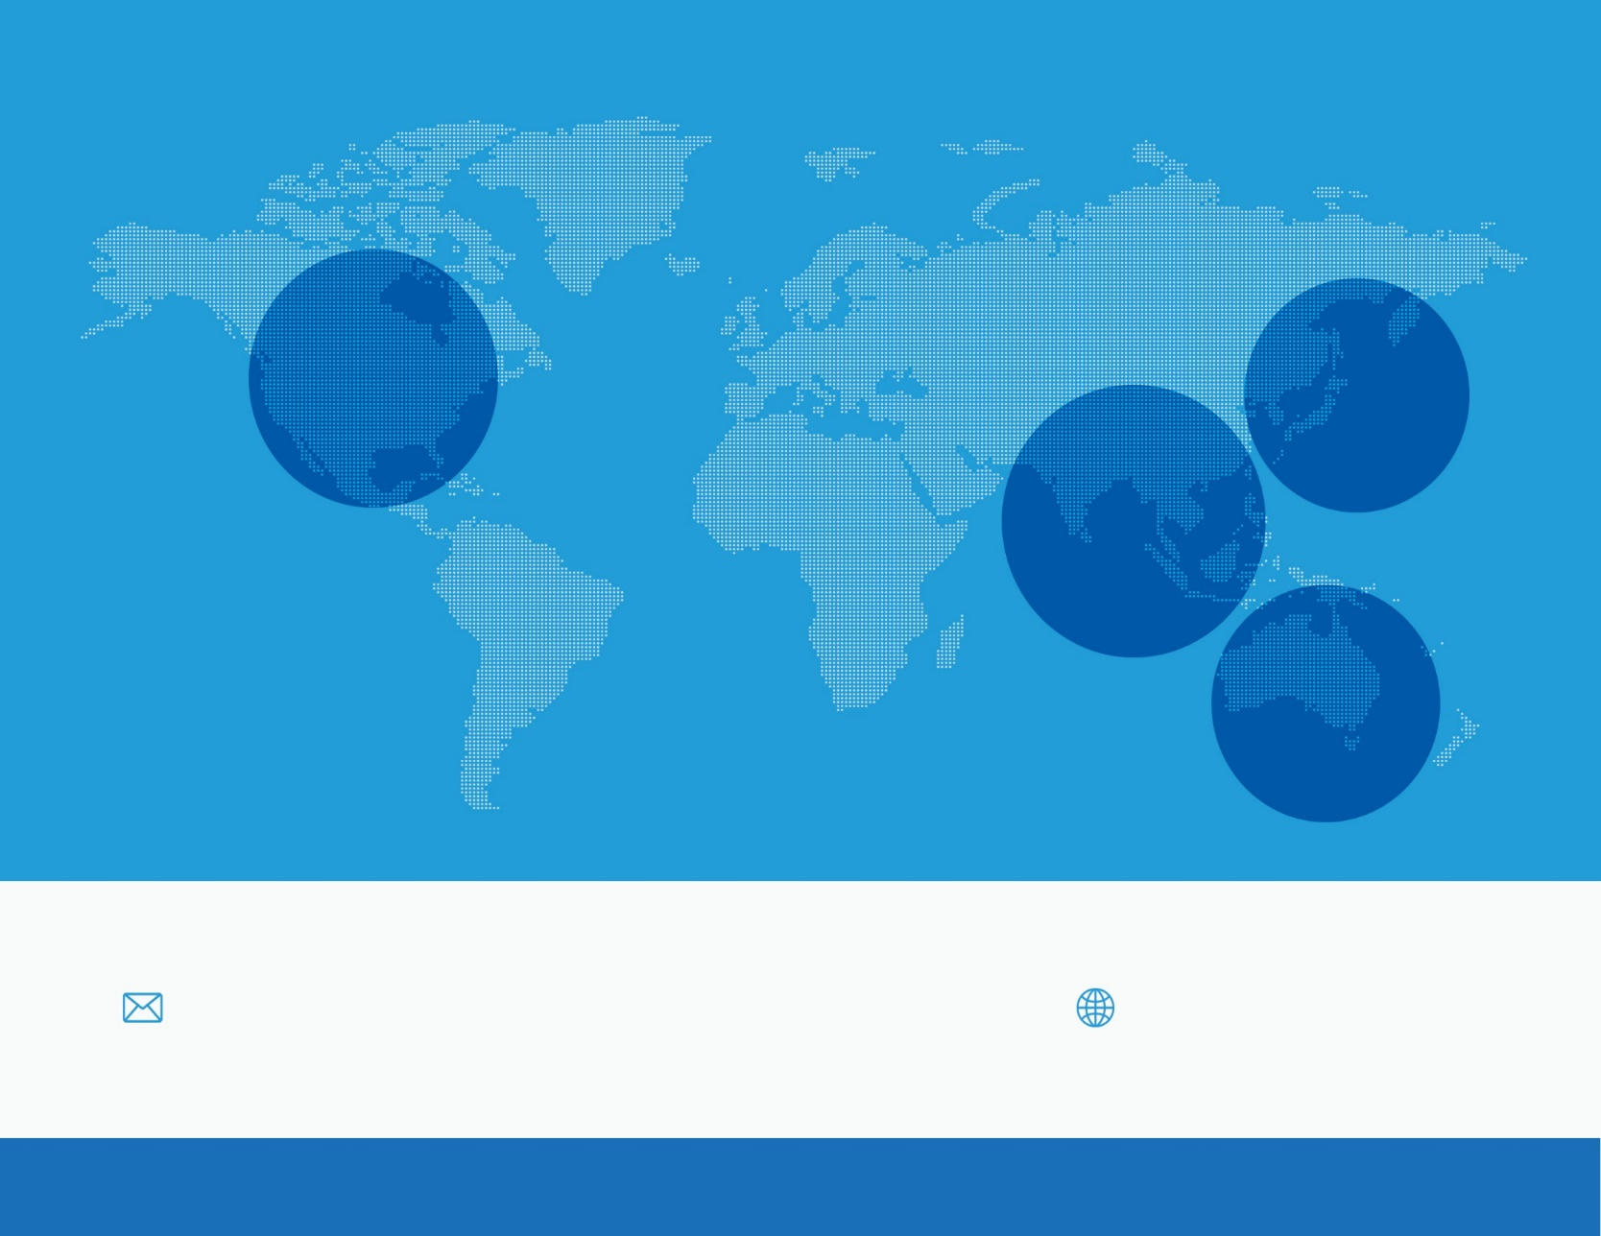

TMA

North America

TMA

Headquarters

TMA Japan

TMA Australia

+ 1 802-735-1392

+ 84 839-951-060

+ 84 839-951-059

+ 84 839-978-000

+ 81 3-6432-4994

+ 61 414-734-277

Email: [sales@tmasolutions.com](mailto:sales@tmasolutions.com)

Website: [www.tmasolutions.com](http://www.tmasolutions.com)

# 3. Industry Experience

### Telecom

* 4G LTE, Wireless and edge router
* Unified Communication
* Network and Access Management
* VoIP, SIP, Asterisk, soft switch

### E-commerce, Retail & Distribution

* Online and mobile store
* Visual product catalogue
* Retail back-office
* Distribution management

### Finance & Insurance

* Wealth Management
* Capital Market
* Financial Analyst Tool
* Insurance Quotation

### Education

* Smart e-TextBook
* e-Library, e-Book
* Learning management
* Student management

### Healthcare

* DNA/GENOME alignment and analysis
* Health device management & control
* Health insurance
* Clinical decision support

### Media & Publishing

* Digital content management and distribution
* DRM (Digital Right Management) technology
* e-Newspaper, e-Magazine, e-Catalog, e-Brochure and e-Flyer (pdf, e-Pub3, custom formats)
* Video and audio player apps (mp3, mp4)

### ISV (Independent Software Vendors)

* Product engineering services
* Application integration
* Porting & migration
* Independent test center

### Hospitality & Travel

* Travel and hotel portal & apps
* Hospitality services platform
* Restaurant POS
* Visual menu app

### Logistics & Transportation

* Smart route
* Traffic data analysis
* Visual Yellow Pages
* Field force automation

# 4. Technology Experience

### Microsoft Technologies

* 14+ years in applying Microsoft technologies to provide effective solutions for companies worldwide
* 400+ skilled Microsoft technologies developers
* Microsoft Partner with Gold Level since 2007
* Many Microsoft technologies certificates
* Experience in many Microsoft technologies & tools

### Java

* 13+ years in leveraging Java technologies to provide scalable and high performance applications for companies worldwide
* 300+ skilled Java developers and architects
* Experience in many Java technologies and tools

### Open Source

* 13+ years in providing open source solutions to worldwide clients
* 100+ PHP, Ruby and Python developers
* Experience in many frameworks
  + CodeIgniter, Symfony, Laravel, Ez, Zoop/Pear
  + Rails, ActiveMerchant, Devise, Resque, Canvas, Social Stream, Redis, Etherpad, Sphinx, Sunspot, Solr
  + wxPython, Django, rabbitMQ, Celery, Mochikit, CherryPy, Kid, SQLObject
  + Magento, osCommerce, Rails e-Commerce, Joomla

### Mobile Applications

* 150 mobile developers
  + iOS
  + Android
  + Windows Phone & Windows 8
  + HTML5/CSS3
  + Xamarin, PhoneGap
* Clients include many global companies in 15 countries in many industries
* Services
  + Enterprise mobility solutions
  + Custom application development
  + Porting apps to new platform
  + Testing
  + Consulting
  + UI/UX design

### Front-end Development

* There are more than 80 HTML5/CSS3/Responsive Web developers
* Skill Set
  + CSS3, AngularJS, Bootstrap & NodeJS
  + Backbone JS, Underscore JS, Require JS, jQuery
  + Durandal JS, KnockoutJS, Ext JS, ReactJS
  + LESS, SASS, EnyoJS, Moonstone, NoSQL
  + Sencha Touch, PhoneGap (Cordova), Titanium, KendoUI

### BI, Big Data and Analytics

* Data integration and aggregation
* Data warehouse, data mining
* Reporting: Cognos, Jasper, Qlikview
* SSIS, SSAS, SSRS

### Internet of Things

* Devices: mobile, sensor, GPS, Beacon, health devices, electronic plug
* Application: Health monitor, smart home, device monitor, remote control, device and staff tracking, retail, M2M
* Wireless, network: WIFI, 3G, BLE, GSM, GPRS, Beacon

### Cloud Application and Migration

* Amazon Cloud, AWS
* Salesforce.com, force.com
* Windows Azure, SQL Azure, Azure Mobile, Signal R, Notification Hub, Azure Service Bus
* Google App Engine
* Application development on cloud platform
* SaaS implementation
* Porting applications to cloud
* Cloud applications testing
* Cloud hosting administration

# 5. Offshore Rate

To be provided later

# 6. Sample CV

To be sent in next phase

# 7. International Standards Compliance

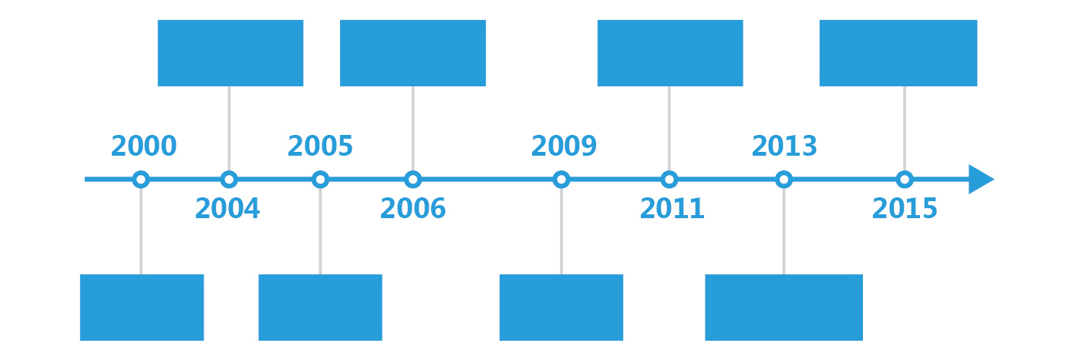

ISO 9001:2000

CERTIFIED

CMMI LEVEL 3

CERTIFIED

CMMI LEVEL 5

CERTIFIED

ISO 27001:2013

CERTIFIED

ADOPTED

RUP

TL9000

CERTIFIED

ADOPTED

AGILE

ISO 27001:2005

CERTIFIED

# 8. TMA Project Models

### Project Models

* **Project-based**
* Fixed price based on requirements
* Detailed project requirements are required for estimating project cost
* **Offshore Development Center (ODC)**
* Dedicated team - Virtual extension of your engineering team
* Customer defines project assignments during project execution

### Project-based Model

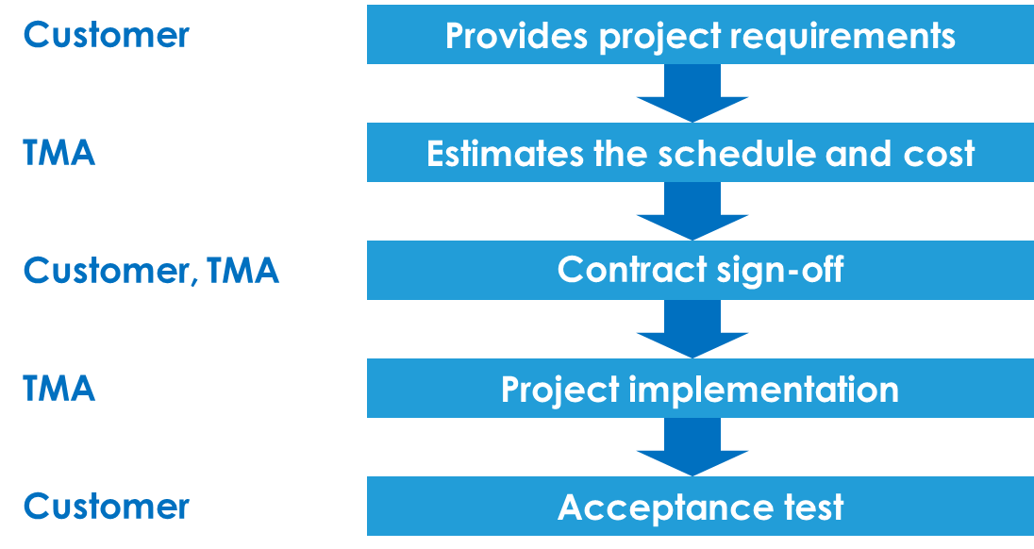

### ODC Model

* **Dedicated team - Virtual extension of your engineering team**
* Team selected by the Customer
* **Stable resources**
* Familiar with Customer’s business, products and processes 🡺 minimize learning curve and increase quality/productivity
* **Scalable resources**

**•** Grow or reduce on demand (1 month notice)

* **Flexible task assignments based on Customer’s needs**

**•** The team can work on several projects at the same time

**•** Shorten the time for starting new projects and reduce contracting overhead for every changes

### ODC Model: TMA’s Roles

* **Administration**
* Staff hiring
* Salary & benefits
* Insurances
* **Basic software and hardware**
* A standard desktop + Windows OS + Antivirus
* Exclude other commercial software like Visual Studio, Microsoft Offices
* **Infrastructure**
* Office space (working rooms + meeting/training rooms)
* Standard office furniture
* Lab space
* Internet connection (including wireless)
* Security: physical, IT, backup & restore
* Power supply 24/7
* Insurances
* **Training**
* Common skills: Policy, Security, Quality, Technical Skills, Soft Skills
* Project specific: by Customer for Core Team, new members by Core Team

### ODC Model: Customer’s Roles

* **Setup phase**
* Select initial team
* Define team structure
* Define process, metrics, communication, timesheet and reporting scheme
* **Operations**
* Assign tasks and allocate resources
* Review results
* Review team and individual performance 🡺 can request for replacement

### Working Hours

* 8 hours/day:
  + 8:30 – 12.00, 13:30-18:00 Vietnam time
* Vacation: 12 days/year
* Public holidays: 10 days/year